



**Group Members:**

Alice Wu

David Speers

Deividas Lavrik

Finn Zhan Chen

Mahbub Iftekhar

Mariyana Cholakova

Michal Dauenhauer

EMILIA’S COMMENTS:

* The prerequisites for the systems are not clear are not obvious

David’s comments:

* Redo software structure like how hardware structure is (1.3)
* 2.1 Make it more concise
* Move turn off robot to replacing batteries section for improved readability

# 1 System Overview

RoboTour is a robotic tour guide that assists people in environments such as museums or art galleries. The system comprises of an autonomous robotic guide, a purpose built Android application, and a web server mediating the communication between the two. RoboTour can be controlled by up to two Android devices, and the tour may be followed by many more. The app allows users to interact with RoboTour intuitively in multiple languages.

The RoboTour has been designed for minimal maintenance once the initial setup has been performed. This guide will outline necessary preparation steps, typical usage examples and a description of nominal behaviour of the robot. A troubleshooting guide is also provided at the end of the document

## 1.1 System Components and Prerequisites

To follow this guide you’ll need:

* An Android device with an SDK of at least 16 (Android 4.1 Jelly bean), and an internet connection
* A computer with Bluetooth and an internet connection.
* The built robot with all the necessary python files installed on the EV3 brick (this is provided for you)

## 1.2 Hardware Structure

### 1.2.1 Robot

The robot provided to you should look like the robot in Fig 1.

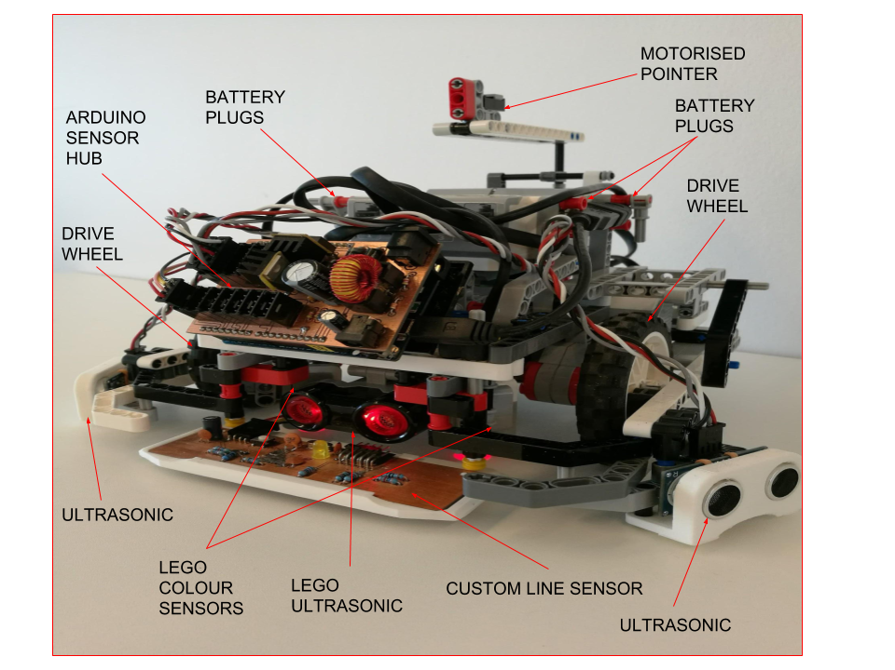

**Fig 1**: Labelled view of RoboTour

Below are a list of components on the robot.

|  |  |
| --- | --- |
| Quantity | **Item** |
| 1 | LEGO Ultrasonic sensor |
| 2 | LEGO colour sensors |
| 3 | HC-SR04 Ultrasonic sensors |
| 1 | Custom Line sensor |
| 1 | Motorised Pointer |
| 2 | Drive wheels |
| 1 | Arduino Sensor hub |

**Table 1**: Robot Components

### 1.2.2 Ports

Table 2 shows which EV3 port connects with which sensor or motor so make sure that these match up upon receiving the robot.

|  |  |  |  |
| --- | --- | --- | --- |
| **Element** | **Port** | **Element** | **Port** |
| Left drive motor | EV3 PORT B | Front ultrasonic sensor | EV2 PORT2 |
| Right drive motor | EV3 PORT D | Sensor hub | EV3 USB host port (Fig 2b) |
| Pointer motor | EV3 PORT C | Left ultrasonic sensor | Sensor hub sensor port0 (Fig 2a) |
| Left colour sensor | EV3 PORT 4 | Right ultrasonic sensor | Sensor hub sensor port1 (Fig 2a) |
| Right colour sensor | EV3 PORT 1 | Front line sensor | Sensor hub I2C port (Fig 2a) |

**Table 2**: Showing which EV3 port connects with each sensor / motor

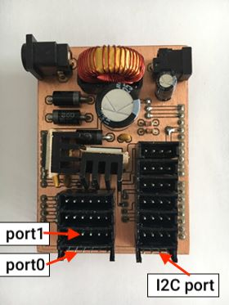 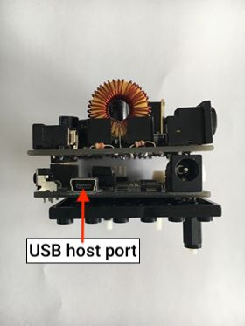

**Fig 2a**: Top of the board **Fig 2b**: Front of the board

## 1.3 Interaction Between EV3 and Android App

The robot and the Android app communicate with each other via a server which hosts a php script. Both the app and robot are able to obtain the server’s state and send a post request to the server to update it. The php script used for the server can be viewed [here](http://proparoxytone-icing.000webhostapp.com/receiver.php). The purpose of this is to allow for multiple users to communicate with the robot. Fig 6 shows the communication between the Android app and EV3 and the process each part does.

The software structure of RoboTour is divided into three layers, the Android app, Server and EV3 respectively (Figure 3).

The Android app layer is where the user can operate the robot and get information from. It includes 5 different modules, which are multi-language, robot control, picture selection, speech recognition and recommendation.

The server layer is where the connection between the App layer and the EV3 layer, with a PHP script inside.

The EV3 layer is where the robot to be controlled. It is consisted by 5 different modules, which are route planning, obstacle avoidance, sensor readings, line following and motor control. The Motor control module includes pointer control and wheel control.

The communications between layers are different. The Android app layer and the server communicate via WIFI or 3G/4G, while the server and the EV3 communicate via Bluetooth tethering.

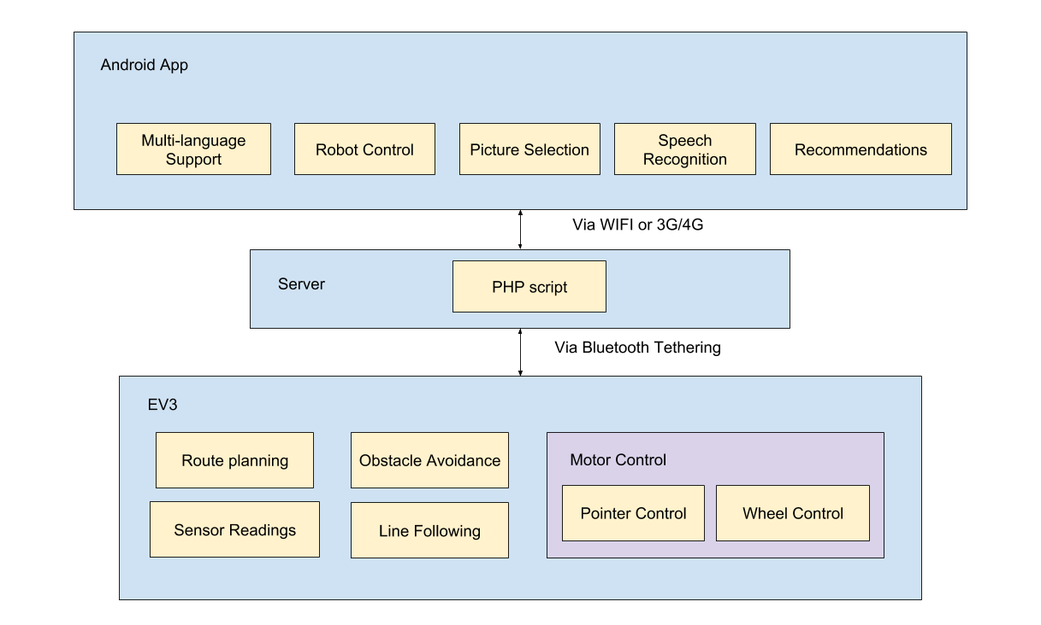

**Fig 3**: Communication structure between Android app and EV3

# 

# 2 Setup and Preparation

## 2.1 Working Environment

The first step to setting up the robot is to recreate the map seen in Fig 4. It is essential that you do not layer tape as this will cause incorrect readings. The robot navigates using 25mm white and black lines on a gray background.

The lines intersect at 90 degrees, and there are no sharp angles on the track apart from the intersections. The intersections have two or more paths leading to them. All artworks must be placed as indicated. On the outside perimeter, there are also black lines indicating the presence of the intersection for the robot in obstacle avoidance mode (see Section [whatever it ends up being]). There is no restriction on the curvature of the tracks, but straight lines contribute to smoother trajectories.

The robot is configured for the environment whose detailed drawing can be seen in Appendix ....

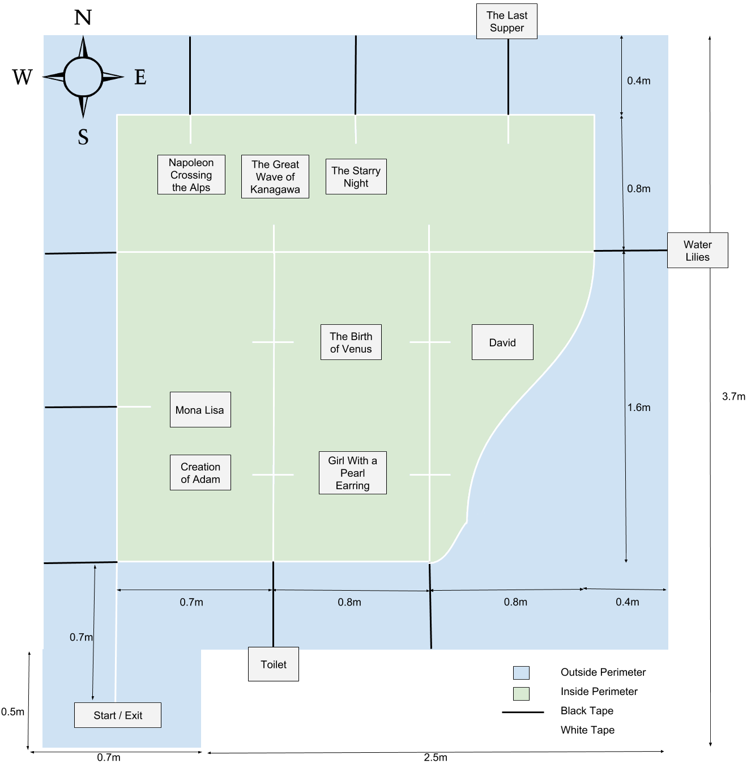

**Fig 4:** Map of the Museum Environment

## 2.2 Robot setup

### 2.2.1

Figure 7 shows the navigation buttons present on the EV3 Brick.

Turn on the brick by long pressing button 4. It takes approximately 40 seconds for the EV3 to start up.

You can use buttons (2,3,5,6) to navigate around the screen, press 4 to select and press 1 to go back.

To turn off, keep pressing button 1 until Fig 5b appears on the screen,then press button 4 (Fig 5a) and the EV3 will shutdown, this takes approximately 30 seconds to complete.

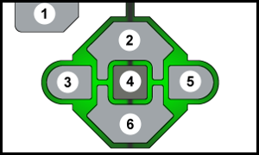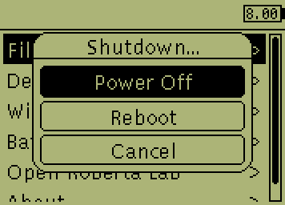

**Fig 5a**: EV3 buttons (ev3dev 2018)  **Fig 5b**: Exit menu triggered (ev3dev,2018)

### 2.3 Bluetooth tethering

RoboTour requires an internet connection to operate. It is provided via Bluetooth connection with a host computer. The computer can be also used to update robot’s firmware or for debugging.

Detailed instructions on how to set up Bluetooth internet tethering for different platforms are available on the

[http://www.ev3dev.org/docs/tutorials/connecting-to-the-internet-via-Bluetooth](http://www.ev3dev.org/docs/tutorials/connecting-to-the-internet-via-bluetooth)

Please follow the guide for your platform.

## 2.4 Software Installation Instructions

To download the app use your phone to go to the following link:

[homepages.inf.ed.ac.uk/s1553593/download.php](http://homepages.inf.ed.ac.uk/s1553593/download.php)

The app will begin downloading automatically.

Once the app is downloaded go to your Downloads app on your phone, find and tap on the file called “RoboTour-App.apk” and follow the installation instructions. Once installed the app will be in your App drawer under “RoboTour”. Tap the app to open it.

# 3 A Typical Tour

If you followed the setup and preparation steps the robot should be on, and connected to the internet and the app should be open on your Android device.

## 3.1 Initialising the Robot

Ensure the EV3 is turned on and has an active internet connection. Place the robot at the starting location, facing “north” (as in Fig …). The robot should be placed directly over the white line, away from any coloured markers.

Using EV3 navigation buttons, enter File Browser and select main.py to start the main program.

The robot will then complete self-diagnosis and calibrate the line sensor by rotating left and right. After this procedure, the robot will say “Please select single or multi user mode” to indicate its readiness.

To select Single User mode press the left button (3).  
To select Multi User mode press the right button (5)

Once you hear “Please select the paintings you want to go to”, the robot is ready to start a tour, which can be initiated using the Android application.

## 3.2 Starting the Tour (App)

Once 3.1 is completed click the “Start” button on your Android device.

The next screen (Fig 6a) will display languages for you to select, if your language is not shown, select the “?”. The description of the art pieces, audio description and all the settings will be in your selected language (provided that your language is supported).

In Fig 6b, you can select which art pieces you would like to see by tapping on the images. You may also choose to search for paintings or ask for recommendations via speech commands by tapping on the microphone or search bar.

The application will recognise commands with following keywords::

* Art Piece name
* Artist name
* “Best”
* “Popular”
* “Recommend”
* “New”

(In your selected language).

After all selections are made, press “Start Tour” and RoboTour will calculate an optimal route plan (the robot will briefly be inactive, while these calculations take place).

(In Multi User mode you’ll need to wait until the other user has made their selections and pressed “Start Tour” before you can continue.)

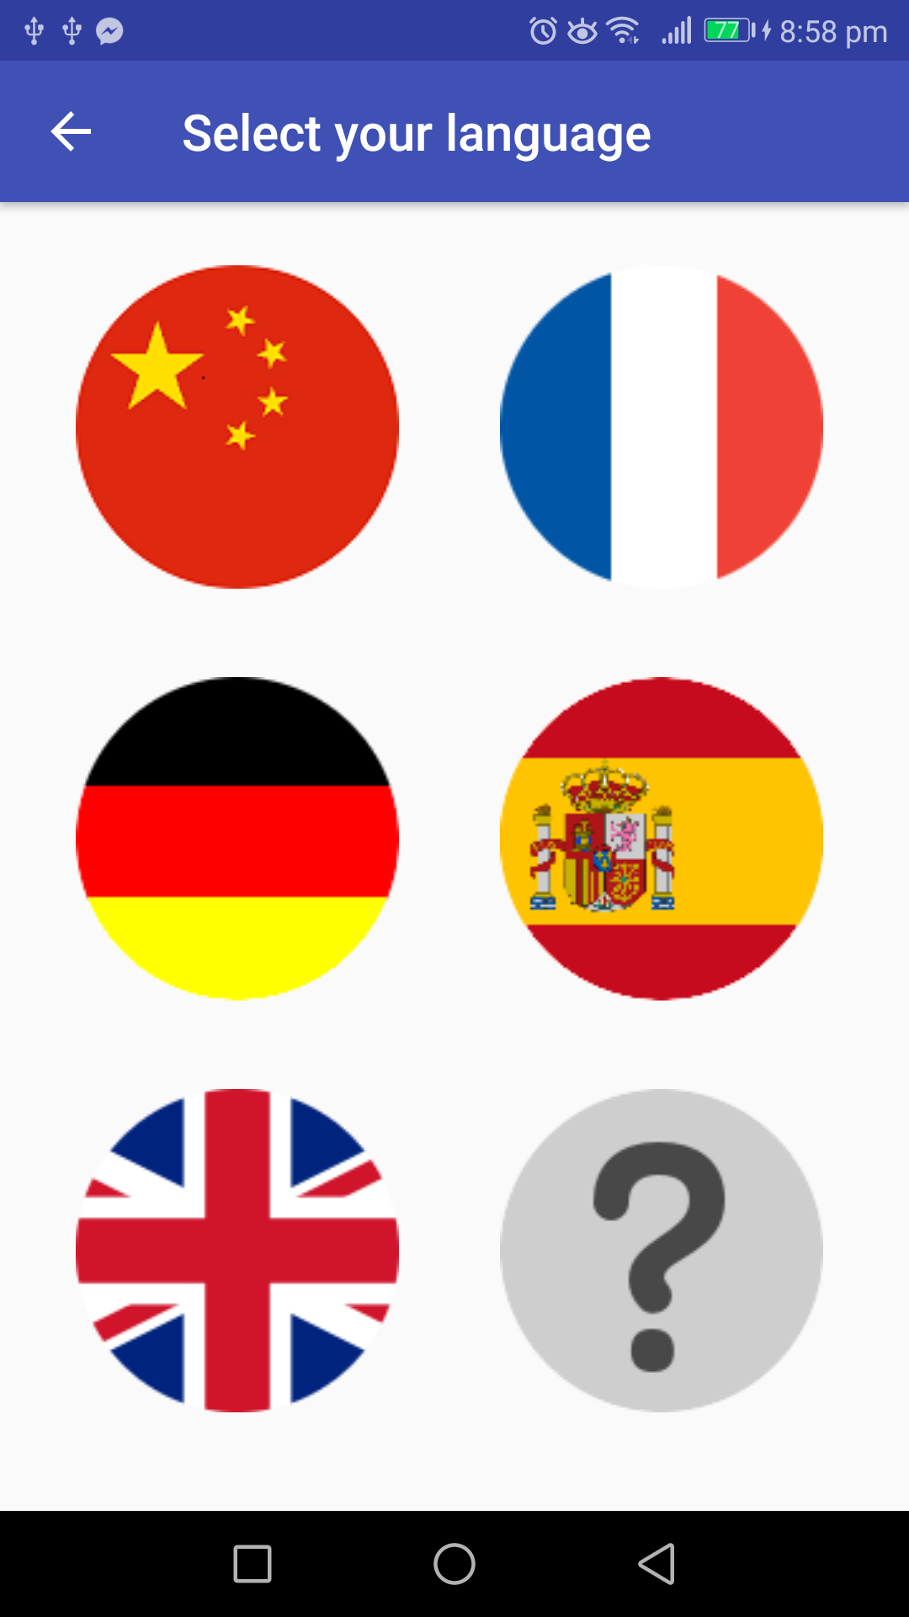 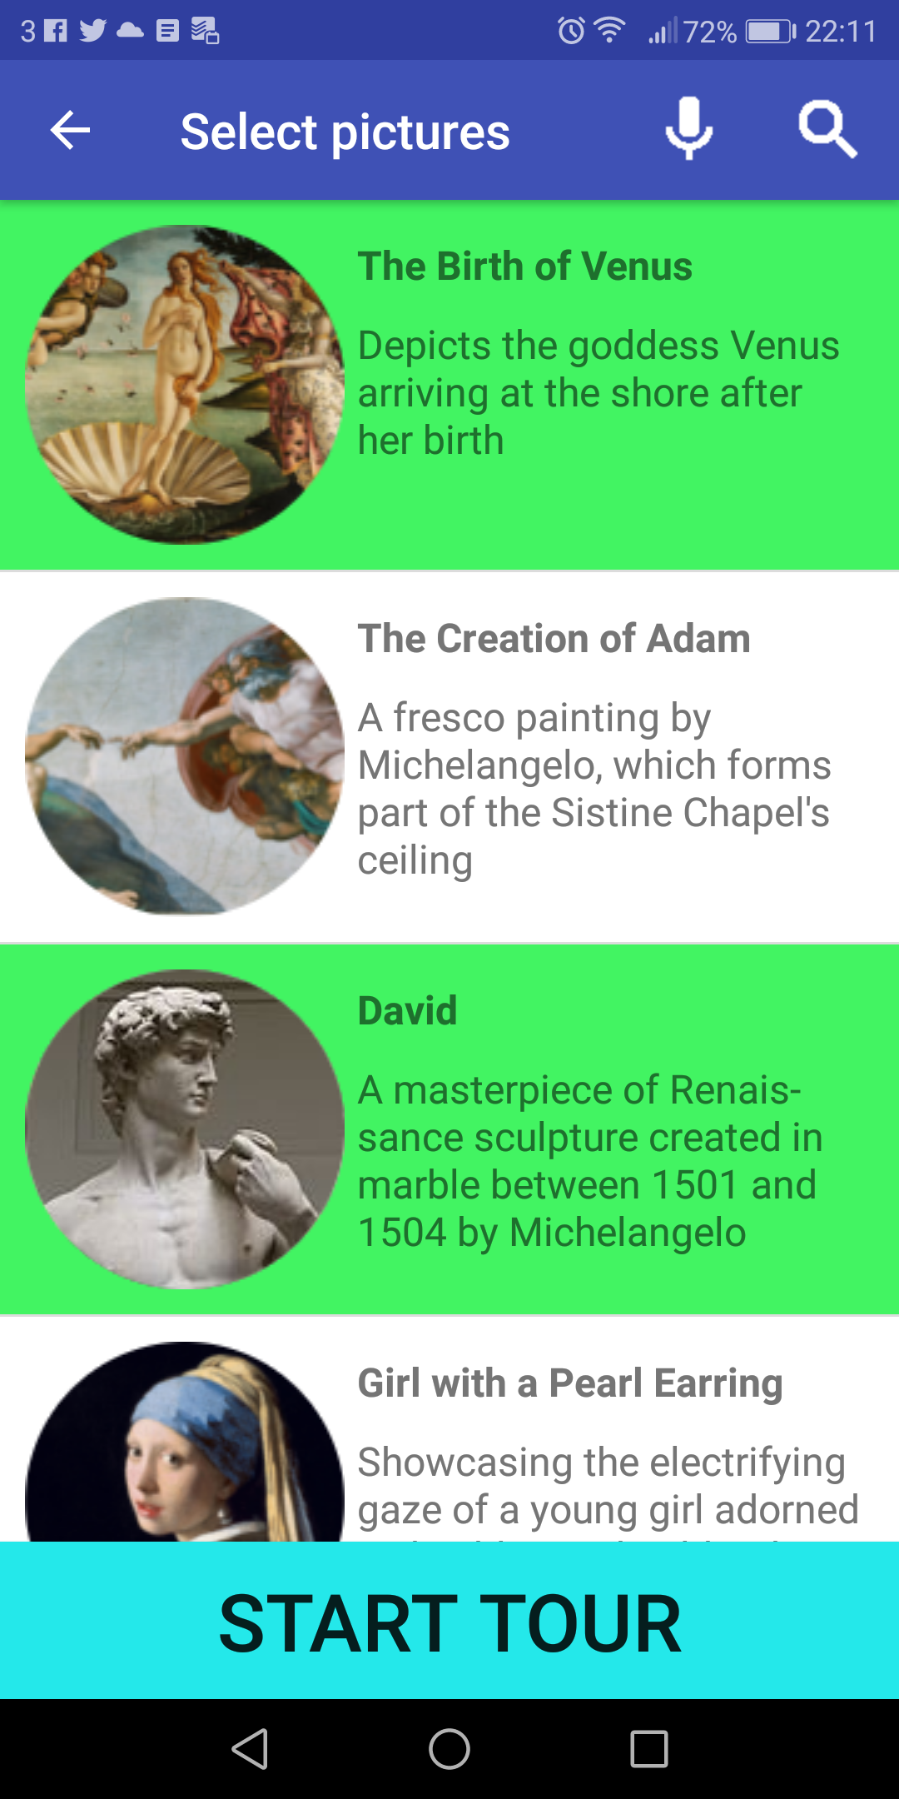 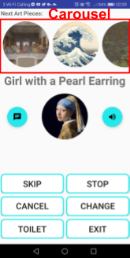 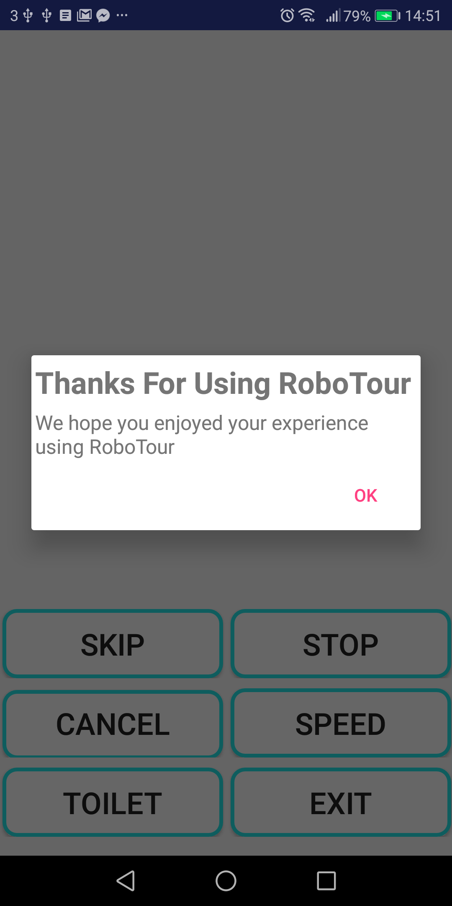

**Fig 6a**: Language Selection **Fig 6b**: Painting Selection **Fig 6c**: Navigation **Fig 6d**: Tour Ended

## 3.3 Following a Tour

After completing 3.1, the robot will follow the white lines guiding you to all the paintings that were selected on the Android device(s). Once it reaches each painting it will stop, the motorised pointer will point at the painting and the app will use text-to-speech to talk about the painting. After the app has finished talking the robot will continue to the next closest painting using Dijkstra’s algorithm.

## 3.3 Robot Interactions During the Tour

When the robot is following a white line and detects an obstacle while it is in the inside perimeter (Fig 4), the robot will just stop and not enter obstacle avoidance mode.

If it’s in the outside perimeter and detects an obstacle, it will enter obstacle avoidance mode:

1. Robot rotates 45 degrees in the direction towards the outward direction of the perimeter
2. The corresponding ultrasonic sensor keeps a certain distance between the obstacle and around the obstacle
3. The obstacle avoidance is completed once it returns to the white line. (See Fig 13)

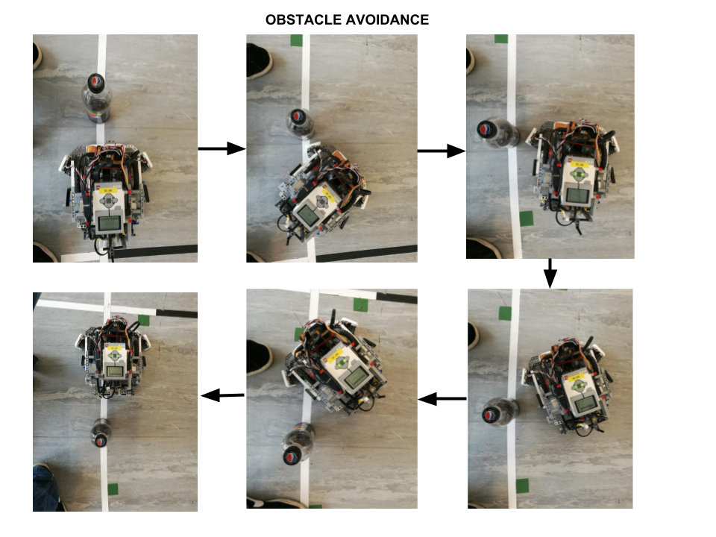

**Fig 7:** Obstacle avoidance

## 3.4 App Interactions During the Tour

During the tour the app will display the navigation activity (Fig 14) . Here you can select any of the buttons to execute the following commands:

* **SKIP**: Skip the current painting

(In Multi User mode an alert will pop up for the other user so that they can accept or cancel the decision).

* **STOP/CONTINUE**: Pause the robot, or continue moving towards the painting
* **CANCEL**: Cancel the tour (robot will return to starting position & app will restart)
* **CHANGE SPEED**: Adjust the speed of the robot
* **TOILET**: Navigate to the toilet
* **EXIT**: Navigate to the exit

Selecting a picture from the carousel will bring up its description, its estimated time of arrival, and the option to remove the painting from the tour. Selecting the text floating action button will bring up the estimated time of arrival, and description of the current painting. Pressing the speaker button will make the application read out the description in your chosen language.

## 3.5 Finishing the Tour

Once all the selected paintings have been visited the tour will end and the robot will return to the exit (the starting position). Once it reaches the exit it will turn around and wait for a new tour to begin. The app will display an alert letting you know that the tour has ended (Fig 15). Pressing OK will restart the app.

### 4 Replacing and Recharging Batteries

To replace the battery first detach the EV3 Brick from the body of the robot. There are eight red safety pins holding the Brick in place. Pull them all one notch away from the brick. You should now be able to lift the brick from the chassis. To release the battery, press on the two latches on the battery pack underneath the Brick.

Insert a new battery pack making sure that the two restrictors feed into their housings. Apply moderate pressure until you hear the latches snap in place.

The batteries last approximately 40 minutes from a full charge, and they take approximately 2 hours to charge from 0 to 100%.

The battery can be recharged with the supplied 10V/700ma barrel plug charger. Connect the charger to the power supply, locate the charging port in the battery underneath the brick (accessible from the back of the robot). Green LED will indicate good connection. Red LED will shine until the battery is fully charged.

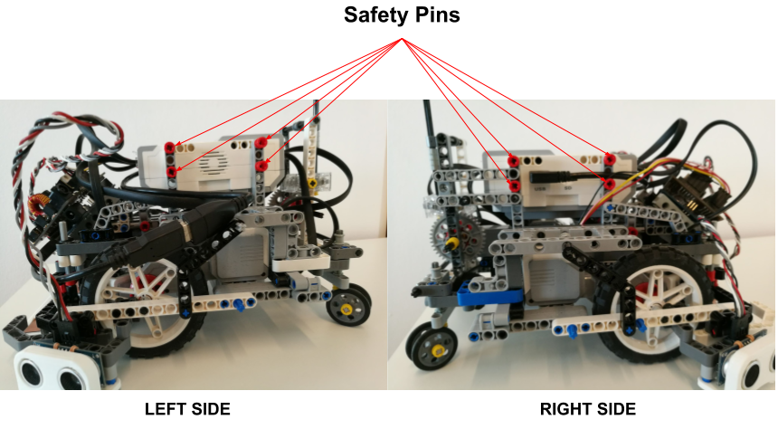

**Fig 8**: EV3 Support Sticks to remove to access the battery

# 5 Troubleshooting Guide

|  |  |  |
| --- | --- | --- |
| **ID** | **Problem** | **Solution** |
| 1 | Robot beeps once and does not start moving after starting main.py | Check if Bluetooth tethering between EV3 and Android device is setup properly, and make sure the device is connected to the internet. |
| 2 | Robot beeps three times and does not start moving after starting main.py | Check if all sensors and motors are connected to appropriate ports. All disconnected devices will be shown on the terminal. Restart the program. If problem persists recharge the battery and try again. |
| 3 | Robot makes a series of short beeps or the front line sensor LED flashes. | Repeatedly press the reset button on the sensor hub and the reset button on the line sensor until the LED starts slowly fading on and off. |
| 4 | Robot fails to avoid an obstacle | Exit the program (See 2.2.1). Hold it until the EV3 exits to the main menu. Move the robot to the starting position and restart the program. Make sure that the ultrasonic sensors are connected properly. Keep in mind that the robot can only avoid obstacles if it’s in the outside perimeter. |
| 5 | Robot does not follow the line properly | Make sure that the front line sensor is at approx. 4mm from the ground and parallel to it. Restart the program to allow recalibration of the sensor. During the calibration make sure that the entire sensor passes over both the white line and the floor, and over nothing else. |
| 6 | Robot stops at wrong markers | Make sure that the lego colour sensors are at approx 4mm from the ground. Restart the program. |
| 7 | Robot is turned on but not responsive to any commands | Force the EV3 to reset by removing the battery and placing it back in again. Turn on the EV3 brick. |

# 6 References